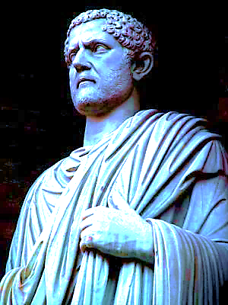
TIME
TO FIGHT FOR EUROPE

9 May, 2016
Aristoteles:
' from the rights of citizens'
to a 'form of government'

Feeling Europe Foundation

MESSAGE FOR EUROPEANS

CONTENT

SUMMARY 1 / 8

INTRODUCTION: EUROPE, WHERE ARE YOU GOING? 2 / 8

WE ARE THE MUSIC MAKERS 3 / 8

BLAMING VERSUS VALUEING 4 / 8

EUROPEAN GOVERNANCE

- Polity 5 / 8
- Sovereignty and subsidiarity 6 / 8
- Decision making and democracy 6 / 8

EUROPEAN IDENTITY 7 / 8

- Freedoms 7 / 8
- Rule of law 8 / 8
- Human rights 8 / 8
- Diversity 8 / 8

FINALITY (recommendations) 8 / 8

SUMMARY

This is a wake-up call at a crucial point in EU history. A galvanising European relaunching in order to ensure a strong, democratic and united Europe. EU citizens need to be made aware of and prepared for needed changes. Target is sustainable EUROPEAN GOVERNANCE and meaningful EUROPEAN IDENTITY.  Euroscepticism and fear of loss of identity threatens integration, while European achievements uptil now -the creation of wealth and well-being- has been undervalued. |  | “A strong, democratic and united Europa and citizens awareness calls for sustainable EUROPEAN GOVERNANCE, and meaningful EUROPEAN IDENTITY”

Should we follow the negative seduction of cartoonists and referenda proponents? Should we be guided by fear and withdraw in our little forts? Should we emphasize what we oppose, what goes wrong?

Or should we strive openly and audaciously for unity in interlinked diversity for the coming generations? And with the zest of a ngo for a sustainable political environment and be thankful and proud of what has been achieved and welcome the coming challenges?

We want to live in peace with hope and trust in our future, acting with reason, compassion and decisiveness, invoking the best of our past, enlisting the best of our human resources.

Would one be willing to die defending our common continent? Let’s honour the dead, the victims of WO II, Madrid, London, Paris and Brussels.
Remember, they will not be the last!

Let future history proof that reformation of the European landscape could be achieved without autocrats and wars.

Main Recommendations

- freedoms and rule of law;
- balancing powers of trias politica, embedding the power of the media;
- balancing universal human and European civil rights and duties;
- balancing diversity and unity, welcoming qualified non Europeans;
- (re)defining the concepts of sovereignty, subsidiarity, federalism and finality;
- reappraisal of the functioning of democracy and its decision making processes;
- rearranging existing European-wide projects and programs to be used as platforms for implementing relaunch:
Main themes for change in cooperation:

- democracy: (in)direct voting and representation, a senate, “regionalisation”, emergency mandate);
- security (defence, bordercontrol, criminal investigation);
- environment & infrastructure (energy, climate control, urbanisation, transport and communication, location of EU institutions);
- funding (e.g. WW II Land-Lease and Marshall plan approach for development and renewal);
- culture, education, and science (citizens exchange programs, “Fulbright” like grants);
- intra european multinational teamwork through social conscription.

1 / 8
INTRODUCTION: EUROPA, WHERE ARE YOU GOING? BRINKMANSHIP OR LEADERSHIP?

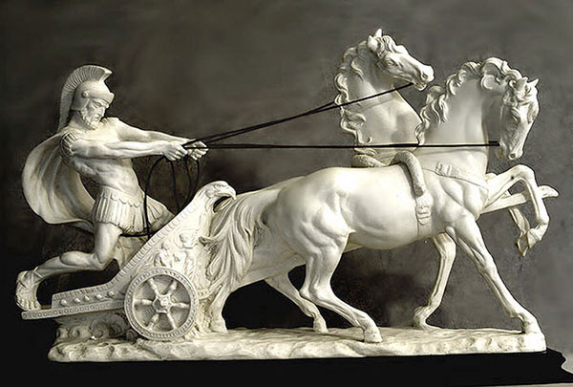  Plato’s ‘Chariot Allegory (Phaedrus 245c-249d’). The chariot-drawn-by-two-horses uses one horse to symbolise human emotion and the other to represent human reasoning. Our conscious behaviours, those driven by noble and ignoble origin of the human brain. There is a great deal of trouble in managing them. |  | Europe faces severe multiple crises that affect one another: the euro, mass physical movement by humans from one area to another, disintegration phenomena and Russian roll of drums. That divides the Union in different ways.  Confused feelings and radicalizing attitudes, permeating European societies ask for the emergence of a shared identity and destiny and a fitting supranational polity for facing current issues that go beyond nation states.  An European relaunch is needed in line with earlier attempts to accomodate its internal balance and to develop a sense of common destiny and interdependence. From Magna Carta, Charles the Great, the Munster Treaty, all the way through the Vienna Congress (which gave birth to the Netherlands) we reached Rome, Maastricht and Copenhagen.

Communality and solidarity slowly gestated in european consciousness. A new impuls comparable to Monnet, Schuman and Delors is imperative at present.
Are we to decide to keep -or even place- ourselves at a distance of each other, or are we to get to know each other and ourselves in European communality?

All this in mind, allowing Europe and its peoples to show what they stand, for their ownership of Europe, we can and should say:

"I value building the European future and companionship, bringing achievements"

instead of

“I blame ‘Brussels’ for loss of sovereignty, wealth, security and identity.”

2 / 8
‘WE ARE THE MUSIC MAKERS’

Europa started the most successful integration experiment of all time, building an ideal of a civil society. It is in this world the largest area with common prosperity and long-lasting peace. That should continue to be a challenge.

The European Union has given birth to the internal market and the reform of the financial sector, promoting free trade, democracy, human rights and the rule of law.

But new politics and policies for confronting the multiple issues are needed for a ‘FIT POLITY’ and a ‘SHARED IDENTITY’. As an antidote to antagonism, we need to talk about other levels of consensus, distribution of voting power and redefine the notion of subsidiarity.

And remember from 1968 that the “one man one vote” referendum cannot and should not supplant representative democracy.

There is a need for more consistency in common political behaviour and for credible authorities making credible promises. And for room of debate and discourse, more continuous dialogue between the world of thoughts, and a good balance between reason and religion, where diversity enriches and where oppression or intimidation will not be tolerated. Culture and science, philosophy and religion matter and contribute to well-being and identity of European human beings.

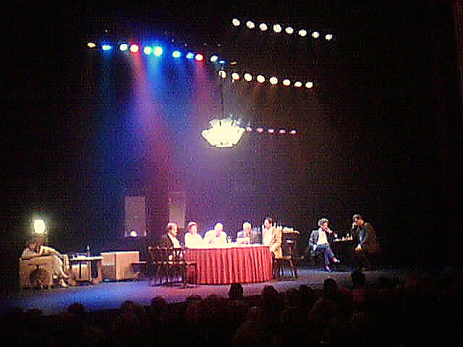

‘Je suis Européen’ (NEXUS Institute)

Calling European Citizens:

"More ‘Feeling’ and Acting Europe is Mandatory"

3 / 8
BLAMING VERSUS VALUEING

"I blame 'Brussels' for loss of sovereignty, wealth, security and identity."

Such a view, accompanied by other symptoms, can give rise to intolerance, and inprocuctive populism, leading to authoritarianism. It is in this light that Europe today is risking to vote democratically to abolish democracy as in 1933.  In the present era, European integration falters by a variety of causes: such as substantial national debts, lack of sound reforms in southern europe, the fragile and vulnerable periphery. Populism, nationalism, and buro-technocracy reign. A fear of loss of local identity, a distate of elitist politicians far away, and an unequal distribution of wealth, foster a preference for tribal interests. As a consequence, serious separatist movements emerge in several countries. Other important aspects are the impact of destabilising geopolitical games by the Russian Federation on the (mid)eastern frontiers, and of the demografic explosions in Africa and Asia. |  | 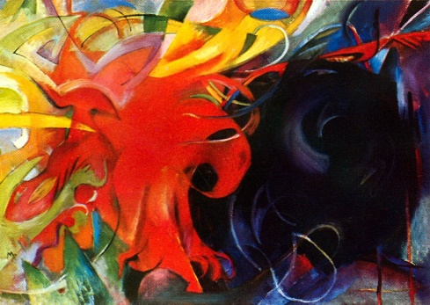  Fighting Forms, 1914 Franz Marc  Propaganda drove a wedge between good and evil, right and wrong

But severe antagonism about internal integration, trade agreements, and further enlargement, leave alone immigration and secular fragmentation, has mounted. It appears that origin and promise of the european venture are at the risk of being lost in the national political bargaining, blaming Brussel's burocracy and avoiding accountability for their own "union" decisions.

It was on April 25, 2016, that the concerned outsider President Obama recalled the achievements that we reached over the last 70 years. In address to the people of Europe he said:

“a strong, democratic and united Europe continues for all of us to be a necessity.”

If Europe wants to become strong, democratic and united, many changes should be stimulated. In the way we act together, pursueing the common goals aspired by the different nations and its regional constituents. Key aspect for moving forward in the process of unification is:

- involving and respecting all interests in a sustainable European governance and
- emergence of a meaningful European identity, embedded by independent media, the 4th power in our Trias Politica.

"I value building the European future and companionship, bringing achievements."

4 / 8

our land mass cannot be governed without a coordinating legitimate polity with delegated authorities

EUROPEAN GOVERNANCE

POLITY

It is the public authority that provides for the encompassing interests. Its objectives are achieved when the different values and interests are brought together and come into consideration for each European to benefit and participate.

Europe has to confront difficult challenges, that are potentially divisive. These common issues relate to the areas of energy & climate, security & foreign policy, economy & finance and the humanitarian field.

But our land mass is not to be governed without a coordinating legitimate polity.

Several Europe states are structured as federal states. We should learn from their democratic experience. The history of federalism as an idea to organize society is invented by the Greeks (2). The cornerstones of this governance of the Union are the Magna Carta (concept of the rule of law), the Trias Politica (concept of the balance of powers), and the U.N. declaration on Human Rights (based on Roosevelt's "Four Freedoms" as the concept of the individual integrity, autonomy and responsibility). They were consolidated in the Copenhagen criteria for EU-membership, emanating their attractiveness and soft power.

The relativity of Europe as such a continental power has however been exposed painfully. All European history points to reaching for synergy of unity. It is now for the grasping. Without a full-fledged polity, the 'Europa administration' will not be able to resolve the lack of clarity about the distribution of its internal powers, its sovereignty and its common decision making and multilevel democratic processes, and thus its application of the concept of subsidiarity. Redefining and institutionalizing interaction at the interfaces of subsidiarity is an absolute priority. |  | “Redefining and institutionalizing interaction at the interfaces of subsidiarity is an absolute priority”
Subsequently the democratic decision making process of representation needs to be reevaluated (district mode, voting threshold, direct for president, simultanious timing etc.). This will have to initiate trust in a new sovereignty in one's own circles of loyalty: local, regional, national, continental and beyond.
Against the backdrop of 'one Europe or none', the principles will be worked out in a practical and comprehensive plan of support, including major funding programs for large-scale investments:

- EU infrastructure, employment, NATO 2%-defense and "Frontex";
- debt redemption through co-developmental fellowship programs;
- priority for Eastern and Southern European countries;
- (re) defining the role Frankfurt and London in EU funding;
- confronting and consolidating two-speed European programs with deadlines, defining criteria for joining.

And all this linked to clear politically stabilizing policies towards Ukraine, Balkans, Turkey and “Northern European left-overs”. And linked to a policy towards integrating internal and external migrants and embedded in a commitment to EU principles.

5 / 8
SOVEREIGNTY AND SUBSIDIARITY

Sovereignty is to right to act in accordance with your own interest. And if seen as necessary regardless of that of your neighbours. Subsidiarity redefines this in a coherent multi-tiered system of authorities and responsibilities.

It is the principle whereby the EU does not take action (except in the areas that fall within its exclusive competence, is sovereign), unless it is more effective that action is taken at national, regional or local levels. The principal should be extended to national, regional and local political levels.
Issues and budgets should be defined and responsibility, authority and accountability should be transparant.

“urgent need arises to sharply focus subsidiarity” |  | It appears that origin and promise of this European approach are at risk of being lost in the national political bargaining, blaming Brussel's burocracy and avoiding accountability for their own "union" decisions.  Thus urgent need arises to sharply focus subsidiarity of several files in the areas of power to (re) define, leading to a consensus on what is European and what the alternative.

DECISION MAKING AND DEMOCRACY

Where and how decisions are made is not really transparant and widely understood. The Treaty of Lisbon, the co-decision or ordinary legislative procedure brings together:

- the Council of Europe and ministers (nation states interest);
- the non elected President (consensus building towards heads of states);
- Parliament (elected every five years by member states' citizens and twice a year observed by 'Vote watch
EU' on the voting behaviour of MEP's) and
- the Commission (to initiate and execute approved EU legislation).

This has become the standard way of decision-making. “Through this partnership between the institutions, the common interests of the European Union, of its Member States and its citizens are expressed in a unique and tangible way, creating the necessary legislation to meet the challenges of the future”.

More transparancy and less complexity will help raise awareness and stimulate participation. The 4th power and digital media should play a major role by providing information on European institutions, national authorities and education-oriented institutions.

Democracy is based on the human ideal of equality for the law. In Western Europe, 21 countries recognize a full democracy (2014). However, the institutions of the European Union are often criticized for a lack of democratic legitimacy, which for a part has been solved since the Treaty of Lisbon (e.g. by the creation of a European Citizens Initiative). But for many, the 'deficit' remains unresolved. This includes the view that the European Union and the President of the European Council operate without a mandate from the people. They want to choose the president in a direct democratic way. They want an integrated functioning of the national and europeanparliaments. They want more regional representation. |  | “CITIZENS WANT:  - to choose the president in a direct democratic way;  - an integrated functioning of the national and European parliaments;  - more regional representation”

6 / 8

Diversity should be cherised as a wealth

EUROPEAN IDENTITY

The concept of identity, sameness, and difference was already considered by Plato. Identity is the unity of being, of total consistency and personal equality. It concerns the set of behavioral or personal characteristics by which an individual is recognizable as a member of a group, the quality or condition of being the same as something else. This part of our culture which always evolves in communities, traditions, manners and lifestyles. In several ways, we are all involved and connected to shared values, common misery, prosperity, well-being and the pursuit of happiness.

The people of Europe form a companionship. The Charter of Fundamental Rights of the EU states that "the peoples of Europe are resolved to share a peaceful future based on rights and common values: democracy, dignity, freedoms, equality, solidarity, tolerance, the rule of law, citizen’s rights, justice.” This announcement, together with our common currency, taxes, and passport formally represents European identity, a framework in which Europeans are connected.

But as long as there exists no comprehensive and sustainable emotional ties a European soul cannot blossom into a widespread European artistic, literary, social and intellectual experience. Leave alone a political.

Economics matters to social prosperity, culture and science, philosophy and religion contribute to well-being and identity of human beings. Companionship, commitment and interaction,  -mutual trust and understanding- as well as intra european education and innovation is needed to inspire relations and to create a Europe where a shared identity grows, and where European values are honored. In this way, Europe and its peoples can show what it stands for and what is not and what it can do and what not.  That there is need for passion, an European spirit and an European consciousness has long been debated. The Nexus Conference “Je suis Européen!” gives us a footing: |  | 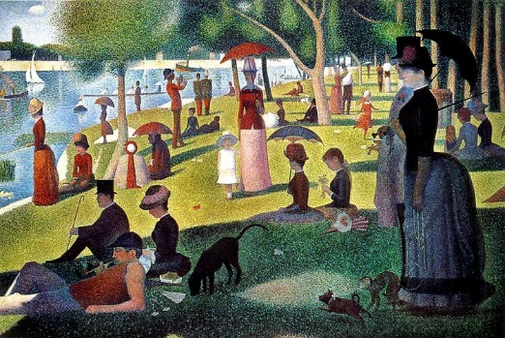A Sunday Afternoon on the Island of La Grande Jatte (Seurat). Members of each of the social classes participating in various park activities,

Jan Patočka (1 June 1907 – 13 March 1977), a Czech philosopher, teaches us: “Europe is born out of concern for the soul, in need of value and meaning.” To the soul, man owes its greatness, because thanks to soul we know of truth, goodness, beauty, love and justice.

“thanks to soul we know of truth, goodness, beauty,  love and justice” |  | Man can personalize these spiritual values in time, that is, not to see them self in a separate eternal world but by connecting them with the world in which we live. Then we are able to transcend the reality of power, property and technology; we are able to transcend ourselves with our slowness, arrogance and leaning towards ostentation.

Caring for the soul is never finished, it should be taught in education and it is throughout our whole life. It is an endeavor to pursue truth in life and justice. Philipp Blom in its turn, a historian, novelist, journalist and translator seemed to hit a core by saying “Je suis Européen, I mean a feeling: to be at home under a European sky and in European values.”

FREEDOMS (the ability to act without restraint)

The EU powerfull and publicy professes the principles of four freedoms, which should form part of the Treaty on European Union:

- economic freedom of ownership, employment and value creation;
- academic freedom of knowledge, education and research;
- communication freedom of expression (including assembly, demonstration) and
- of media (including information and privacy). 7 / 8
RULE OF LAW

A pan-European Party for 'Freedom, Growth and Harmony' (‘EP-FGH’) should strive for redefining legislative, executive and judicial power distribution as well as the balance between those powers in a democratic way.

HUMAN RIGHTS

Article 14 of the Universal Declaration of Human Rights states that "Everyone has the right to seek and to enjoy in other countries asylum from persecution." Europe need to instutionalize social protection against poverty, discrimination, exploitation as well as physical protection against aggression, torture, poor health, and exclusion.

DIVERSITY

Europa is the continent with a grand history of rich culture, varied nature, monumental architectural styles, brilliant thinkers, artists and unique typical binding characters throughout history. Brilliant painters, creative architects, unique writers, brilliant footballers, matchless composers, great philosophers and scientists and statesmen made unprecedented furore.

Paul Klee, “Ad Parnassum / Polyphony”, 1932 |  | Diversity should be cherised as a wealth

However, the acclaimed diversity of Europe without growth in unity becomes a sectarian burden; one lives in worlds increasingly drifting apart filled with one’s own individual truths. The current diversity, the differences in development, prosperity, culture, religion, history and "umwelt" perception becomes a threat rather than a source of enrichment (value).

There is need for continous dialogue between the worlds of thought and for balancing between reason and religion. Separation of religion and state are absolute. Threats can be turned into opportunities if pan-European projects were to be staffed by "social conscripts”, aiming to promote understanding between citizens of Europe.

FINALITY (recommendations)

- Promulgate in an explicit and rallying declaration “The Finality of Continent Europe”;
- Ad now an exclamation mark to Copenhagen criteria, ending its open-endedness, and make a start defining our Europe what it is, what it should be, what it stands for, and what it is worthy to live in, to contribute to, and die for our common:

polis of freedoms, rights, justice and democracy
cultural and religious history
innate drive to create wealth, knowledge and innovation
instinct to reinvent our own destiny
geography and borders.

- Do this reflecting ourselves in relation to and with adjacent continents the America’s, Africa, Russia and the Asia’s;
- Putting on hold for later generations to consider extending membership outside this continent such as a Byzantium/Constantinople, Istanbul revisited.
8 / 8
- a form of government in which sovereignty is shared between the central or national or federal level and the states. The individual parts (states) is often assigned a relatively high degree of independence. In federations ever established by then independent states, there is a national or federal level only by the grace of those states. The sovereignty is thus divided between the whole (the federal state, the national government) and the parts that have their own legal order;
- city states under pressure from exclusion from Black Sea trade access by Troy, and from Persian imperialism, were forced to cooperate democratically in consensus. From this concept they developed their "polis", competing by speech, by politics, in polity, the art of governance. Rivalry was channeled by olympic sports in "Agathè Eris" or noble competition, in cooperative trade and defense agreements, defending their common values and interests.

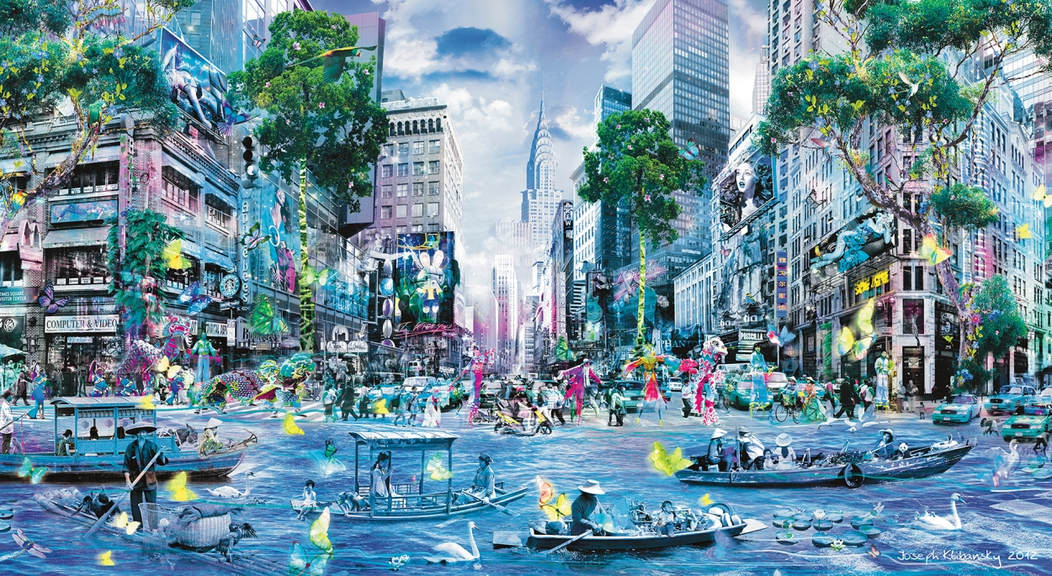

Parade of Change, Jospeh Klibansky

